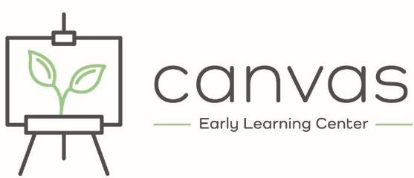
For Office Use Only:
Date Received: _______

Room: ______________

Priority #: _________

Registration Request
Please fill in or circle all pertinent information
Child’s Name: _____________________________________ Nickname: ____________________ Male Female
Birthday: _____________________________
Parent(s) Name(s): ___________________________________________
Address: ___________________________________________________
Contact Phone Number: ______________________________________
Contact email: ______________________________________________

Requested start date: ________________________________ (Canvas needs a minimum of two weeks’ notice before your child begins)
How did you hear about us? Newspaper/Dillonite Radio Referred by: ____________________________
Social Media Online Search Other: ____________________________________

What schedule are you seeking for your child? Mark all that apply | Enrollment Fees
Full Day Half day* After school  _____ ______ _____ Monday  _____ ______ _____ Tuesday  _____ ______ _____ Wednesday  _____ ______ _____ Thursday  _____ ______ _____ Friday  *For Half day indicate AM (7:45-12) or PM (12:15-5:15)  ____Drop In Membership | Registration Fee: $50  Materials Fee: $50  (materials fee will be charged upon enrollment in addition to the regular trimester schedule)  * Scholarships do not pay for fees unless specifically noted in the agreement. Fees are the responsibility of the parent.

Monthly Tuition Rates
 | Infant - Toddlers |  | 2-3 Year olds |  | 4-5 Year Olds |  | After School | Drop-In Membership
 | Full Day | Half Day | Full Day | Half Day | Full Day | Half Day | 3:30-5:30 | as available
4-5 Days/wk  3 days  2 days | $800  $600  $400 | $500  $375  $250 | $725  $545  $365 | $455  $345  $230 | $675  $510  $340 | $425  $325  $215 | $195  $145  $100 | family membership  0-23 months  2-3 years  4+ years | $25  $10/hr  $9/hr  $8/hr

Waitlist Priorities: Our general waitlist is based on first-come-first-serve. However, waitlist for fall recognizes returning families as a priority until August 1st. After August 1st, all families are considered on a first-come-first-serve basis for available openings.
Email this form to: aaron.canvaselc@gmail.com or bring in to the Center at 512 ½ North Washington OR 434 Poindexter St. A welcome email will be sent to you as well as any additional information to enroll your child. Please note that this form is for our waitlist only and does not reserve a space for your child.

